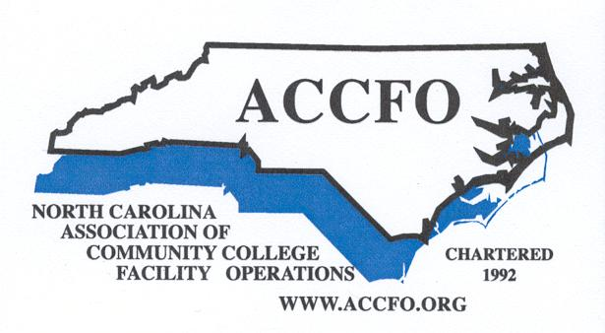

ACCFO Retired Members

Don Caudle, Edgecombe Community College
Lee DuVall, Guilford Technical Community College
Larry Henderson, Craven Community College
Gary Johnson, Mitchell Community College
Barbara Moser, Guilford Technical Community College
Scot Quesenberry, Forsyth Technical Community College
Tommy Rhue, Carteret Community College
Jim Robbins, Caldwell Community College & Technical Institute
Dan Sitko, Guilford Technical Community College

